Writing Task 1
Muhammad Umar Farooq

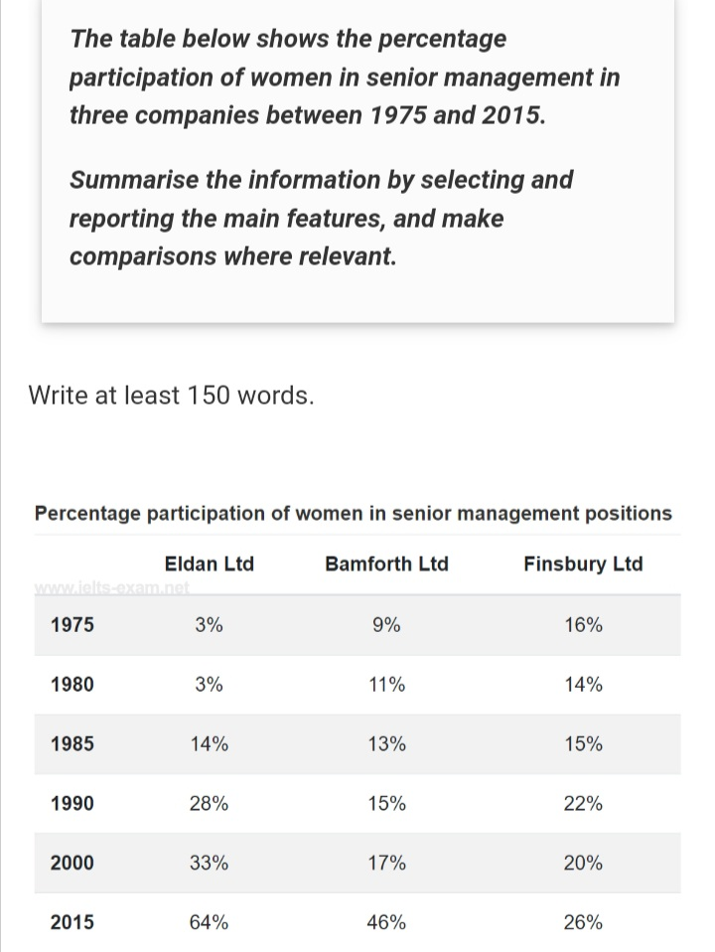
Statement: The table below shows the percentage participation of women in senior management in the three companies between 1975 and 2015.
Solution:
The table illustrates the ratio of women in higher administration positions in Eldan, Bamforth, and Finsbury from 1975 to 2015.
Overall, both Eldan and Bamforth showed an increasing trend, whereas Finsbury demonstrated fluctuations throughout the period.
From 1975 to 1985 Eldan stood at 3% in 1975, which was 6% lower than Bamforth and 13% lower than Finsbury. Eldan remained constant at 3%, and rose to 11% for Bamforth and 14% for Finsbury in 1980. However, Eldan reached 14% compared to 13% for Bamforth and 15% for Finsbury in 1985.
In 1990, the percentage of women in top management rose 28% in Eldan, 15% in Bamforth, and 22% in Finsbury. Moreover, Finsbury had a downward trend, with Eldan reaching 33%, Bamforth 17% and Finsbury 20% in 2000.
In the final year, Eldan reached a peak of 64%, while Bamforth and Finsbury stood at 46% and 26% respectively, respectively, both showed overall growth over the period.

